  

**Vision X**

Sustainable Mobility

**Introduction**

**Objective**

Vision X is an electric vehicle project that deals with design , optimization and construction of an all electric sports bike for the Indian market. The bike has been designed to exceed the performance of existing internal combustion engine counterparts while delivering equivalent range and pricing, compared to a 200cc vehicle. The bike significantly brings down carbon emissions and promotes a green alternative to fossil fuel based vehicles.

The prototype has been demonstrated at the Carbon Zero Challenge, hosted by IIT Madras and the US Consulate General where it was given highly positive feedback. A second prototype is currently being developed to improve ergonomics and safety while optimizing cost parameters to make it wallet friendly.

**Who we are**

Our Team consists of a diverse group of students from the Electronics and Mechanical departments who believe in making a difference and impact in the world right now, because a better future doesn’t build itself.

We are based out of the “EV lab”, PES University, Bangalore. We are currently working with Eko vehicles, an Industry with a vast experience in the field of electric vehicles. We are also assisted by CORI (Crucible of Research and Innovation), a platform through which we have access to leading experts in fields including but not limited to Battery technology, Electricals and Electronics, Computer Science, Materials Science.

**Team List:**

|  |  |  |
| --- | --- | --- |
| **Name** | **USN** | **Role** |
| Saurabh Jacob Kuruvila | **01FB16EEC252** | **Team Lead** |
| Rupith Baburaj | **01FB16EEC237** | **Electronics Lead** |
| Bharath B Mahadikar | **01FB15EME034** | **Mechanical Lead** |
| Aakash Hegde | **01FB16EEC002** | **Display Module** |
| Aasish Tammana | **01FB16EEC003** | **Peripherals** |
| Pratheek S | **01FB16EEC199** | **Charger** |
| Adithya K | **01FB16EEC016** | **Battery management System** |
| Pavana Kumar B S | **01FB16EME709** | **Mechanical assembly** |
| Siddanna Mahadev Masali | **01FB16EME714** | **Mechanical assembly** |
| Guru Prasad Patro | **01FB16EME706** | **Chassis** |
| B. Arjun Bhat | **01FB14EME037** | **Transmission** |
| Harshith J | **01FB14EME060** | **Drive train** |
| Achuta Anekal | **01FB16EEC013** | **Financials** |
| Aditya Anekal | **01FB16EEC018** | **Market Analysis** |

**Carbon Zero Challenge**

* Carbon Zero Challenge (CZC) : Develop carbon neutral systems and grid-free infrastructure to serve five major sectors which are plagued by energy shortages/costs.
* Organised my IIT- Madras, and the US Consulate General
* The grand challenge: Develop a grid free alternative system which is economically viable, environmentally friendly, and easily replicable Urban housing, Transportation systems, Agriculture and Water and Waste management facilities.
* Open to students and/or early stage entrepreneurs of Tamil Nadu, Kerala, Karnataka, Pondicherry, and Andaman and Nicobar Islands.
* Online submissions
* Maximum 25 teams selected
* Provided with expert mentorship
* Prototype funding upto Rs 5 lakhs per shortlisted project.
* Final Prize Money: Rs 25 lakhs

**How we’re doing it**

We’re starting off with the chicken in the chicken-egg problem, since a rudimentary “egg” exists. A compelling cost effective performance all-electric motorbike with a strong visual presence in order to change people’s perception of electric vehicles and help

accelerate the transition to EVs.

● Future forward - easy implementation of future technology

● Modular - Components can be swapped out as necessary

● Augmented experience - Redefine riding through AR

● Clean Design - Simple,elegant yet powerful and alluring, minimal life-cycle effect on

environment.

● Majority recyclable Parts - Eco friendly in a true sense

● Intelligent - Improves performance with usage data

**Market Report**

**Members :**

* Aditya Anekal
* Achuta Anekal

**4W analysis (Why, when, where, who) and Market Analysis**

India is the second largest motorcycle market (10.5 million produced in 2015 of a total of over 16.1 million two-wheelers) and the fourth largest commercial vehicle manufacturer in the world.

As of 2012 129.5 million 2 wheelers or 74.2% of motor vehicles were 2 wheelers.

People in pioneering EV markets like US don't really use motorcycles that much. And those that do, are the loud Harley Davidson types so it makes sense.

Therefore, we are targeting developing markets, which predominantly consume and use a lot of 2 wheelers. Even places like Europe, where two wheelers are used extensively can be a market after proving quality and reliability and performance.

India has NEMMP- national electric mobility mission 2020 which incentivizes EV’s and relevant infrastructure and Mission 2030 mandates only electric vehicles to be sold from 2030.To expedite its electric mobility mission, the Indian government

is reportedly seeking investment from a number of companies,both domestic and foreign. 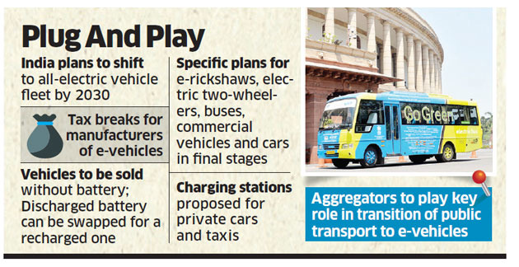

We wanted to make a high performance EV and change the perspective of people about EVs. Our target segment is the 200cc vehicles with whom our motorcycle’s performance is comparable.

By proving to people that EVs are capable of performing at par and even better than high performance IC bikes we will be achieving our objectives.

Although our motorcycle will be priced a little higher,our goal will be to first capture the market, garner attention without having to sell a great number of bikes.This will help create brand awareness and gain customer loyalty.

We land ourselves in a very competitive but at the same time a unique market:

Major competition comes from two wheeler manufacturers who build conventional bike in 200cc category are KTM Duke 200,TVS Apache,Bajaj Pulsar ns200 Fazer,R15 etc.But the electric market is whole new ball game with a few established players like Tork,Emflux, and Ather in case of scooters.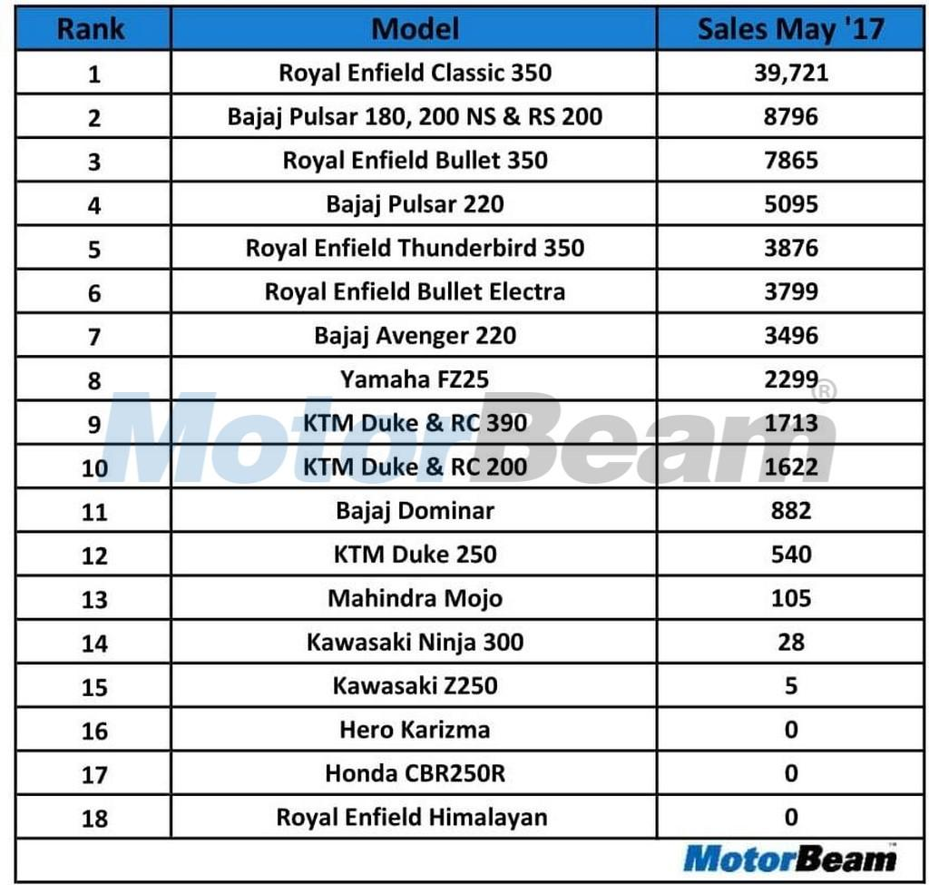

Another key area in which we want to take on our competition in marketing. Our marketing is going to be done in a more non-traditional way. We’d love ‘word of mouth’,promote a incentivizing referral plans and use use social media to our advantage media to be our primary advertising source

In order to develop a charging infrastructure we have plans to tie up or seek partnership with power supply companies like BESCOM.

We believe in making the source of power to be as clean and green as bike will be by using renewable energy to generate the required power to charge our bikes.

There is also great potential for exporting it to Asian countries (SEA) with similar markets.

We believe deeply in the Make In India mission and our hope is that in the near future we are fortunate enough to have every part of our bike made in India!

**Electronics Report**

**Description:**

Sub-domains:

1. Battery and Battery Management System
2. Charger
3. Motor

**Mentors:-**

* Dr. Venugopalan S
* Dr. Rex Joseph

**Team members in Electronics:-**

* Saurabh Jacob Kuruvila
* Rupith Baburaj
* Adithya K
* Aakash Hegde
* Aasish tammana
* Pratheek S

**Objective:**

* Build a cost effective high voltage , high capacity lithium battery pack
* Procure 3 phase BLDC Motor to provide high performance capabilities of the bike
* Determine SOC , Voltage and Current of the battery pack to maintain optimal use conditions.
* Modulate performance of the motor by optimizing Motor Controller parameters.
* Display relevant system information to the rider via interactive GUI

**I. Battery and Battery Management System:**

Specifications:

* Cell Type Lithium Polymer
* Cell Capacity: 75Ah
* Cell Voltage(Peak): 84V
* Cell Voltage(nominal): 72V
* Discharge Amperage(P): 350A
* Discharge Amperage(Continuous): 150A
* Operating temperature : 20-60 °C
* Battery Management System:
  + Over Voltage Control
  + Under Voltage Control
  + Over Current Control
  + Temperature Control

Cell Characteristics:

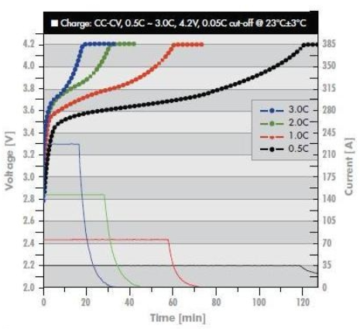 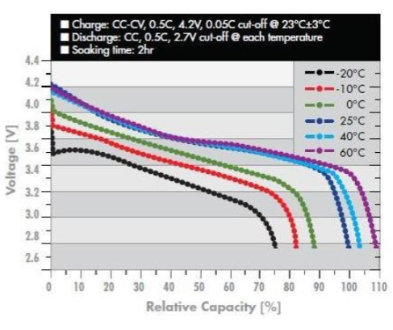

*Charge profiles at room temperature Temperature Characteristics*

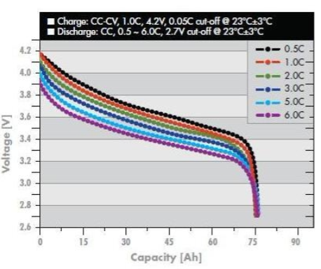

*Discharge profiles at room temperature*

**Comparison of lithium ion polymer cells with lead acid batteries**

1. Weight: Lithium-ion batteries are one-third the weight of lead acid batteries
2. Efficiency: Lithium-ion batteries are nearly 100% efficient in both charge and discharge, allowing for the same amp hours both in and out. Lead acid batteries’ inefficiency leads to a loss of 15 amps while charging and rapid discharging drops voltage quickly and reduces the batteries’ capacity.
3. Discharge: Lithium-ion batteries are discharged 100% versus less than 80% for lead acid. Most lead acid batteries do not recommend more than 50% depth of discharge.
4. Cycle life: Rechargeable lithium ion batteries have a cycle life of 5000 or more compared to just 400-500 cycles in lead acid. Cycle life is greatly affected by higher levels of discharge in lead acid, versus only slightly affected in lithium-ion batteries
5. Voltage: Lithium-ion batteries maintain their voltage throughout the entire discharge cycle. This allows for greater and longer-lasting efficiency of electrical components. Lead acid voltage drops consistently throughout the discharge cycle
6. Cost: Despite the higher upfront cost of lithium-ion batteries, the true cost of ownership is far less than lead acid when considering life span and performance
7. Environmental Impact: Lithium-ion batteries are a much cleaner technology and are safer for the environment.

**Comparison of cylindrical cells with pouch cells:**

Cylindrical cells have good mechanical stability and are easy to manufacture. When mounted, they have spaces between them to install thermal regulation solutions.

We chose pouch cells as they are flexible, lightweight and compact. They can deliver high load currents. This significantly increases range and capacity while utilising less weight and volume. The pouch cell makes most efficient use of space and achieves 90–95 percent packaging efficiency, the highest among battery packs.

Pouch cells tend to swell after 5000 cycles( for our cell model). Hence, we spaced the cells at a safe distance to overcome this problem.

**Challenges with lithium ion batteries:**

1. It requires a BMS(battery management system) circuit for overvoltage and overcurrent protection.
2. Cell aging: Degradation upon storage is accelerated at SOC=100% (4.2V)
3. Lithium cells are very susceptible to changes in temperature.

**II. Charger:**

The objective of the battery charger is to draw power from the AC mains ,convert it to the desired DC voltage and channel it to the battery. This must be done in the shortest possible time without damaging the battery.

The charger has been selected after a lot of literature study, we also spoke to the engineers at emflux motors, an electric motorbike company.The charging system here consists of 2 parts.

1. Boost converter with power factor correction.
2. Buck converter

* The boost converter consists of a rectifier, which converts AC to DC, the boost converter steps up the voltage from 220V to 350+V.
* Power factor corrector and a filter circuit is required to keep the grid isolated from the charger and to reduce wastage of power which is caused by the charger.
* The buck converter steps down the voltage to desired voltage to charge the batteries, the voltage varies with the CC-CV stage of charging.

**Selection of Converter**

Battery chargers are required to charge the batteries, in a certain period of time depending on the charging mode. Charging is stopped when the cells reach a particular voltage, for most Li-ion cells this voltage is 4.18V to 4.2V.

Detection of the voltage at which charging has to be stopped is very important, Li-ion cells are especially sensitive to overcharge .If the cells are overcharged, their lifespan is reduced significantly and the SOH is adversely affected.The TI BQ76940 IC monitors and controls charge termination.

Battery chargers are non-linear loads, they cause the current and voltage waveforms to be out of phase with the input waveforms. This phase difference causes results in reduction in power factor. A lower power factor results in inefficient use of power due to which power is wasted. Most battery chargers introduce noise into the system, higher the power greater the noise, this can have a huge impact on the grid and may also cause the grid to collapse. To isolate the grid from the noise from the charger a filter circuit is used. A power factor corrector is used to keep the power factor as close to unity as possible.

Charging happens in two stages, Constant current(CC) and constant voltage(CV).

1. CC - This is the first stage of charging ,in this stage , the charging current is kept constant for a short while, after a certain period of time the charging current gradually drops.
2. CV -for most part of the charging, voltage is kept constant, the voltage becomes constant around the time the charging current starts to drop.When the cell voltage reaches 4.2V charging is terminated.

b.Charging Rates

Batteries can be charged at different rates. The rate of charging simply refers to the rate at which charge is put into the cell, it determines the speed at which the batteries are charged . The “C rate’’ is a measure of speed of charging.

C Rate * t = 60mins

Where t = time taken for charging (in minutes)

1. **Slow charge** - takes around 14-16 hours. This is the simplest method , the charger required is also very simple in construction. This method is rarely used to charge Li-ion batteries due to the long charging time and also because Li-ion cells can not tolerate being overcharged. This method is only used when the Li-ion cells is discharged to a voltage below 3V and needs preconditioning charge.
2. **Fast charge** - takes 60 - 80 mins. This method takes less time but presents the danger of overheating and overcharging and requires chargers that are more complex. There is generally no single charger that can be used for all types of batteries and requires specific chargers to be made for specific cell chemistries and capacity. A temperature cut off is required to prevent overheating and end point detection is very important.

**Conclusion**

While in most cases fast charging is required, charging the batteries around 0.5C should be done whenever possible, this helps extend battery life and performance.

**Specifications of System**

a. The procedure for arriving at the specifications for the battery charging circuit system is as follows:

1. Look at various electric vehicle manufacturers’ charging system design.
2. Use the calculated results and refer to electrical engineering and electronics engineering material to calculate variations in said specifications across components and circuits.

specifications:

1. Input: 230 VAC 50 Hz
2. Output: 84V and 20A
3. Constant Current/Constant Voltage Mode
4. 3.5 hour Charge time.

**III. Motor:**

Electric Motors are classified mainly (i)DC and (ii)AC.

Literature study suggests that while both are highly efficient, the exact application of the motors causes a minor difference in the efficiency. Factors such as torque/power requirement, range of speed, and mechanical stress affect the performance of the motor. After significant research, BLDC and PMSM motors were the top two choices for use in electric motorcycles. Due to the significant cost of BLDC motors at the performance level necessitated in this particular application and factors such as magnetic hysteresis and magnetic losses in BLDC motors, the PMSM motor was chosen as our primary option.

**SPECIFICATIONS:**

**•** Designed for 24 to 96 VDC battery applications (350 and 700 V option)

• Continuous Output of 12.9 kw on 96 VDC battery systems (30 kw peak)

• Maximum rotor speed is 8,000 rpm (Passes 11,000 rpm rotor burst test)

• Totally Enclosed, IP65 rating.

• UL Insulation system, Class H

• Designed to meet NEMA 1004 standards

• NTN6006 LLUC3/5K sealed ball bearing (Made in Japan)

• Sine/Cosine Rotor Position Sensor (Hall Sensor option available

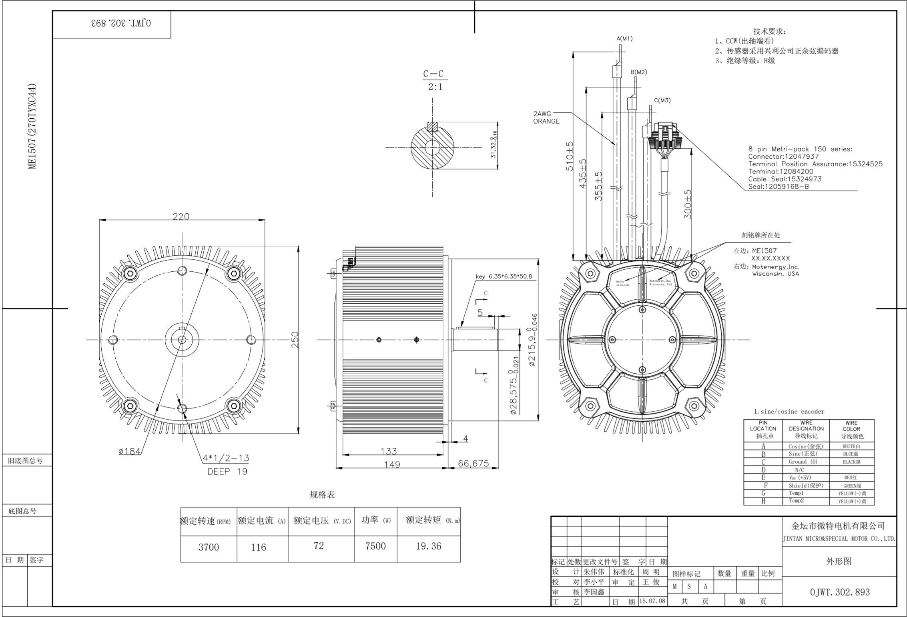

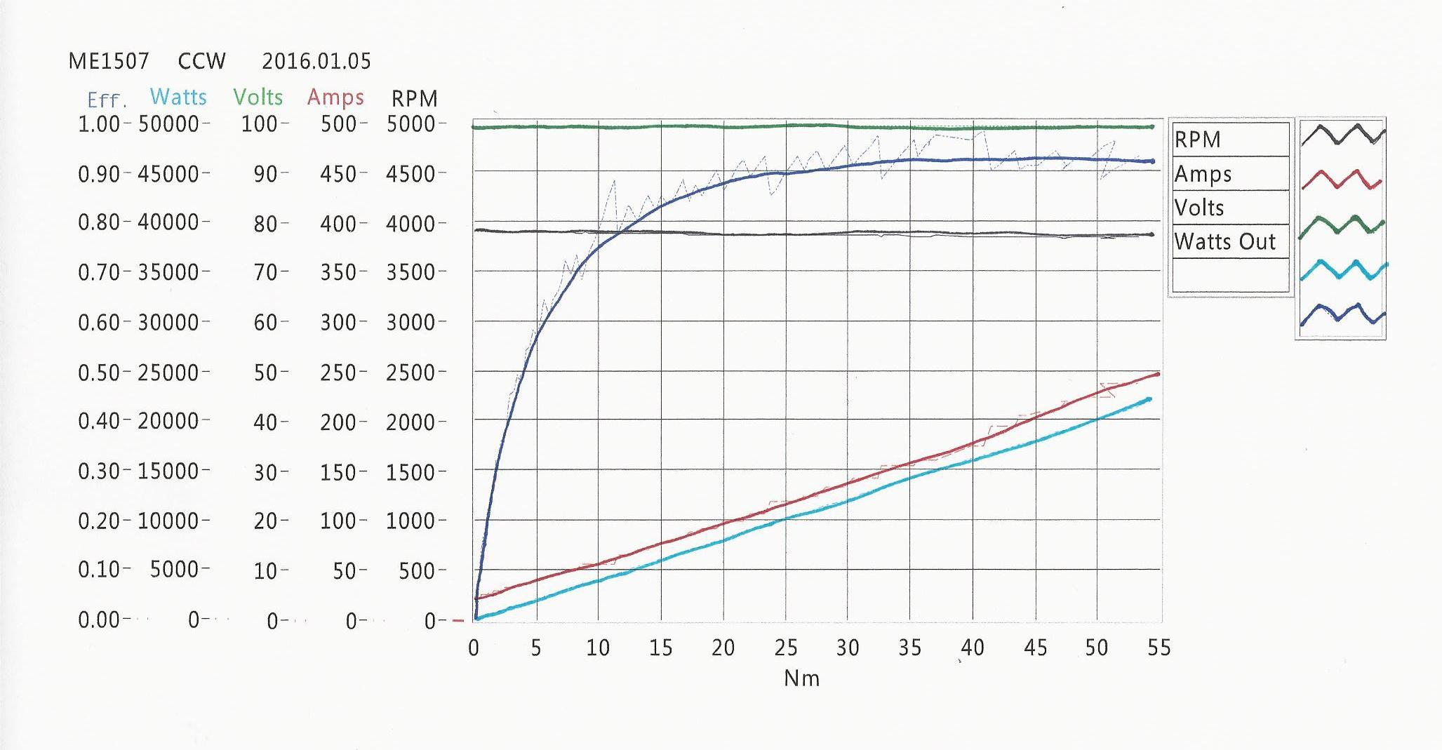

References:

1. <http://www.relionbattery.com/blog/7-facts-and-figures-comparing-lithium-ion-vs.-lead-acid-batteries>
2. <http://batteryuniversity.com/learn/article/types_of_battery_cells>
3. <http://www.relionbattery.com/blog/lithium-cells-should-i-go-cylindrical-or-prismatic>
4. <http://www.electrohms.com/product/hk400t03/>
5. <https://www.diodes.com/assets/Datasheets/AH180.pdf>

**Mechanical Report**

**Mentors:-**

* Dr. Suresh Nagesh
* Prof. S. S. Patil
* Prof. Ponangi Babu Rao
* Lalitha Anil

**Team members in Mechanical:-**

* Bharath B Mahadikar
* Pavana Kumar B S
* Siddanna Mahadev Masali
* Guru Prasad Patro
* B. Arjun Bhat
* Harshith J.

**Introduction**

**Objective:**

To build a frame or chassis which will be able to sustain the loads of motor and battery with better speed and torque?

To enhance and optimize the structure of chassis depending on the size of electric components.

To reduce the emissions to minimum and to switch to green energy.

**Procedure:**

Basically we are using the existing chassis to build to prototype electric bike, for which we selected the chassis of Bajaj pulsar 220F bike.

The following are the factors for selection of the chassis of above bike.

It consists of double cradle chassis, which will provide maximum volume to place motor and battery conveniently.

According to the data obtained for this bike, it can withstand 18N-m of torque with factor of safety of 1.5. As we have limited motor torque to 20N-m, so ideally speaking it is not crossing the critical point of chassis because of FOS.

Initially we modeled the chassis by reverse engineering method over existing chassis.

Then according to the dimensions obtained for motor and batteries, we planned with different mountings to be established to hold the components rigidly to encounter the vibrations.

In Power flow from motor to rear wheel, we used single reduction mechanism to get the desired torque and speed.

Based on mountings decided to place the components, we further entered to analysis using Hypermesh software which gave us a result of stresses induced in the chassis after loading of the components.

Based on the outputs in the analysis and manual calculations, we came up with the decision for the type of materials procurement is needed to build the mountings.

After material procurement, we worked on assembling the components in the most optimized way.

**Team breakdown**

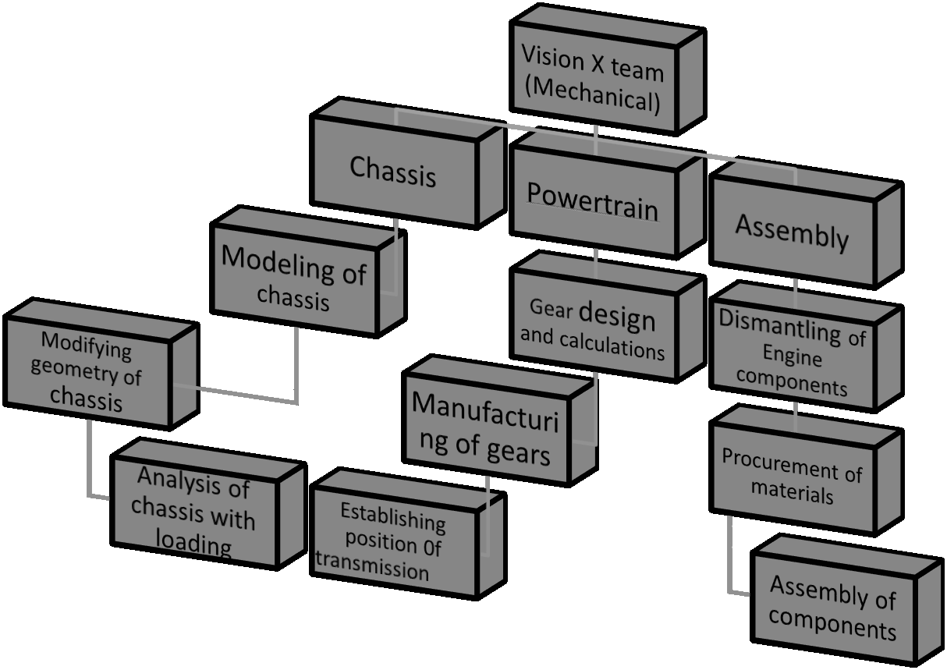

**Chassis design and analysis**

Basically we created a concept of using existing chassis by keeping it as independent geometry and customized the structure of motor and battery packs.

The following are the major components of Electric bike.

1. BLDC motor of 20KW

2. 84 volts battery pack further divided into three packs

3. Motor controller

4. Contactor

5. 12 volt battery(lead acid)

6. Set of gears to enhance power

Above components are fitted at one of position to held it rigid by depending on the space and constraints of the existing chassis

Geometry of chassis(Double cradle) over which components to be fixed.

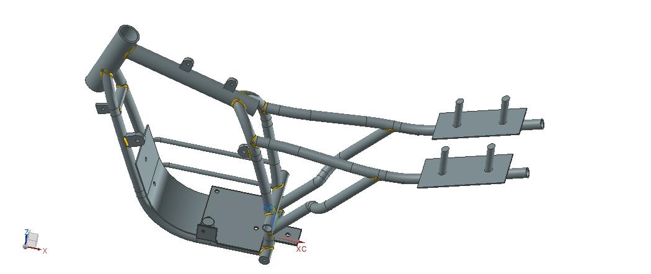

Previous figure describes the geometry of chassis which was existed after removing all the engine components.

The figure below describes the geometry and position of components established after various testing and analysis is done. This figure shows the appropriate positioning of components.

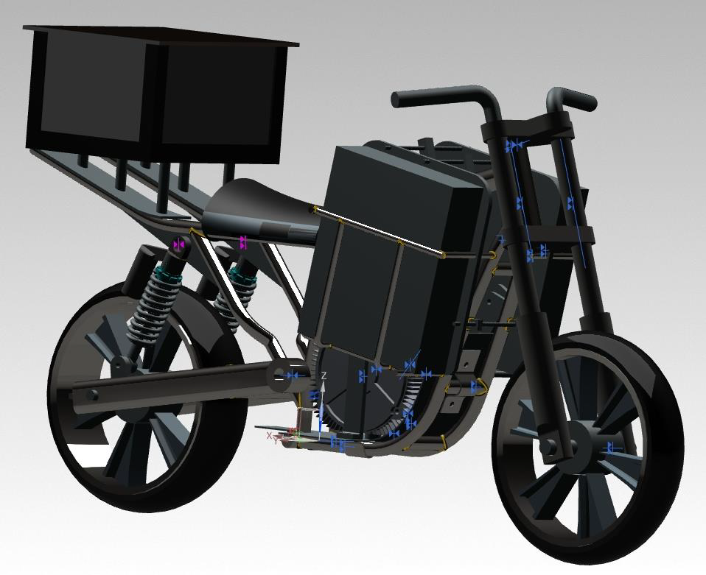

The figure below illustrates the position of the components.

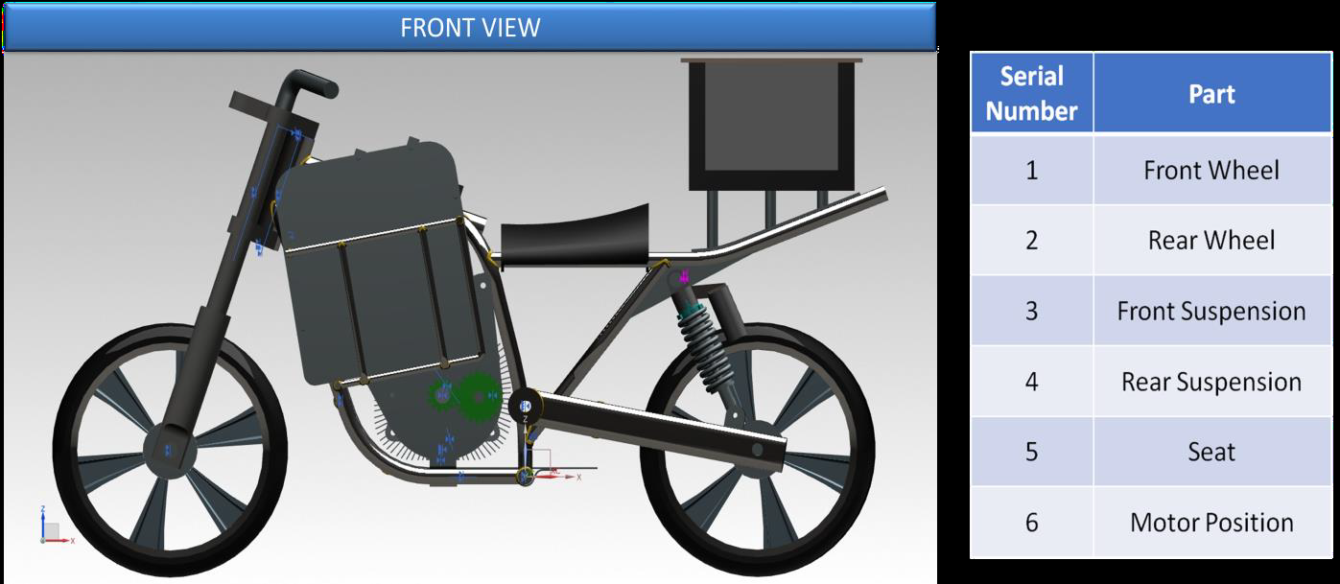

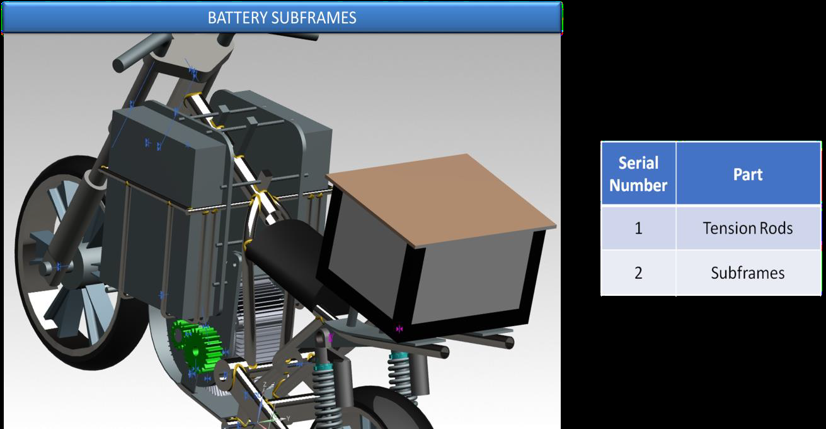

**Chassis Analysis**

Steps implemented to analyze the forces in chassis

* Meshing of chassis
* Determining the forces acting over chassis
* Applying boundary condition to analyze
* Modal analysis of chassis
* Static analysis by considering FOS as 1.5

**Meshing of chassis**

For meshing of chassis, we used Hypermesh software. We selected quad elements of size 3mm for 2d mesh and tetra element for tetra mesh. We created mid surface of the tubes in the chassis to get better result. 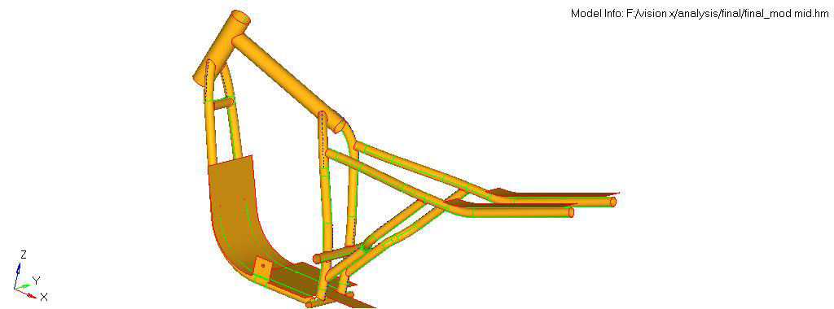

**Meshed views**

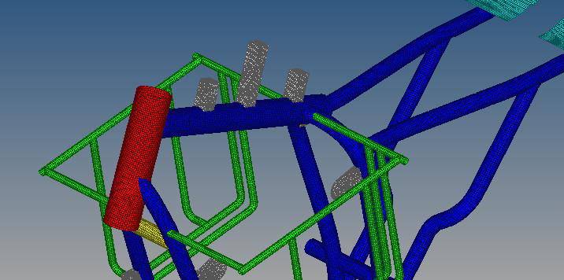

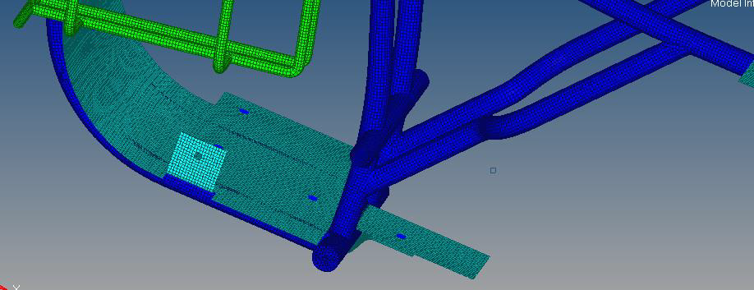

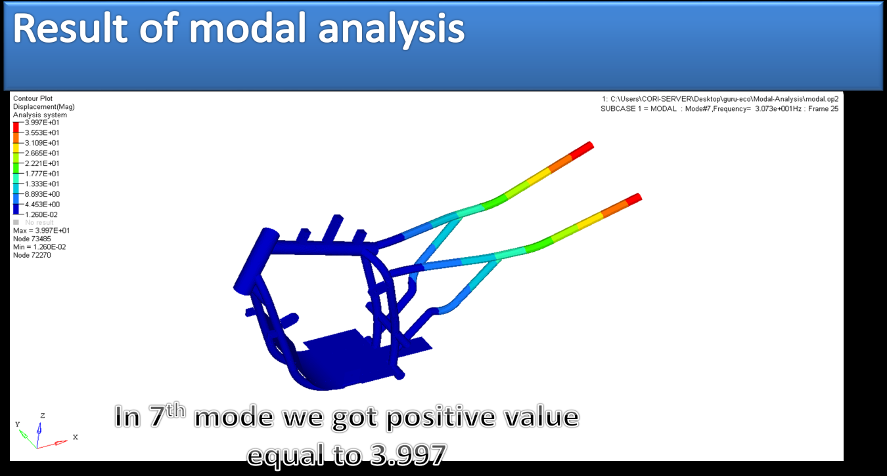

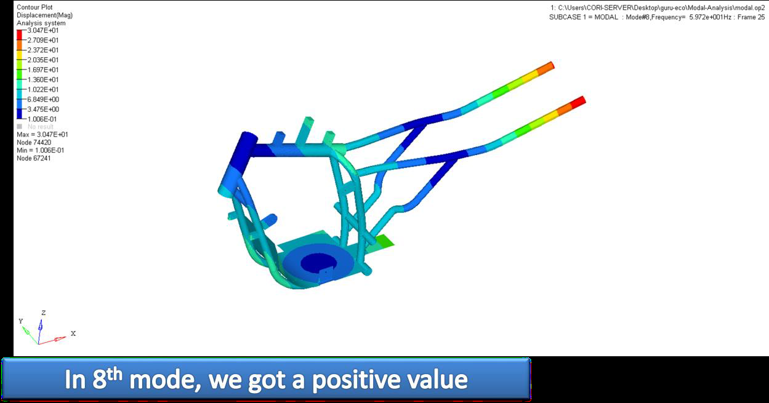

**Static analysis**

Following are the factors considered for static analysis:-

1. Material –Mild steel

2. Motor weight-35kg

3. Battery packs on front-15kg

4. Battery pack on rear- 37.5kg

5. Young’s modulus- 210Gpa

6. Poisson’s ratio-0.33

7. Density- 7.83exp-9 tons/mm^3

8. Yield stress- 250Mpa

9. Bondary condition- Steering column and rear suspension is considered as fixed

**Loading condition**

Fixed steering column Fixed suspension point 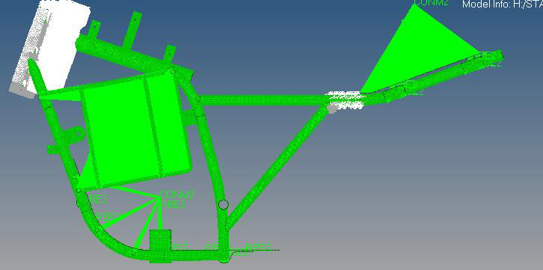

Stress result in static analysis

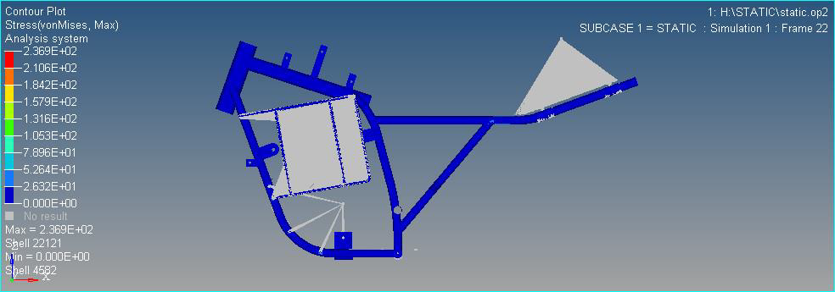

Displacement result

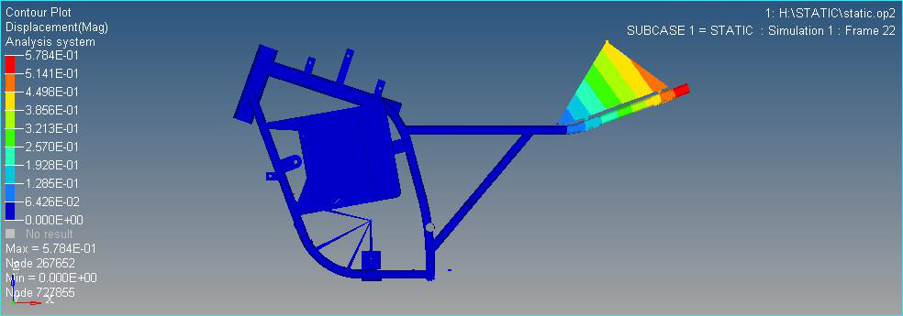

Materials used to position the components as follows:-

1. M8 and M6 bolts to hold the base plate and rear plate

2. Mild steel hollow pipes to treat it as subframes to hold front batteries

3. Mild steel plate of 2.5 mm thickness with hardening to hold motor

4. Tension rods to hold battery

5. Dampers to counteract the vibrations

6. Bearings and Gears for establishing transmission

**DRIVE TRAIN**

**Objectives:**

The drive train is the power transmission means of the vehicle. Power to the rear wheel has to be effectively sent with maximum efficiency and minimal losses. The gearbox must be designed to ensure minimal vibrations so that there are no alterations due to centre distance variations.

The following section contains all the parameters and details of the drivetrain, and necessary maintenance points.

**Drivetrain Selection:**

Following were the options available for power transmission:

a) Direct belt drive

b) Direct chain drive

c) Gear drive primary reduction, chain drive final

Below is the comparison of the three drives:

|  |  |  |  |
| --- | --- | --- | --- |
| **Parameter** | **Belt** | **Chain** | **Gear-Chain** |
| Pitch line velocity | <40m/s | <25m/s | >40m/s |
| Power Capacity | Low(<10 kW) | High | Very high |
| Torque Capacity | <20Nm | >20Nm | Well above 40Nm |
| Efficiency | 95 | 98 | 100 |

Considering the above factors, with our motor transmitting 20 kW and upto 60 Nm of torque, and that the vehicle already has a chain drive, we decided that choosing a primary reduction as a gear drive would be optimal.

**Drivetrain Design:**

Following parameters were considered for drivetrain design:

a) Maximum Centre distance: 68 mm

b) No casing, scant lubrication

c) Maximum torque: 60 Nm

d) Maximum power: 20 kW

Type of gear chosen: 20 degree involute Spur gear

Reason for choosing spur gear: no axial loads (helical gears suffer axial loads, so an axial load bearing would be required)

Material chosen based on supplier’s availability: 20MNCr5 Steel

Core hardness: 250 BHN

Surface hardness: 600 BHN

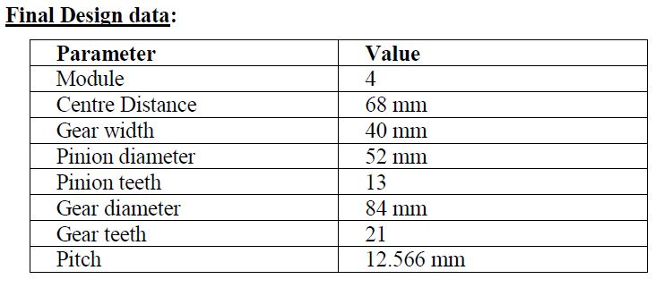

**Gear mounting:**

a) Pinion is keyed directly to the motor shaft.

b) Gear is keyed to the shaft carrying the final drive sprocket.

c) Driven gear shaft is mounted as an overhang beam due to space constraints.

d) When looking from the drivetrain side, the sprocket is behind the driven gear, and goes directly to the wheel sprocket.

**Gearbox supports:**

Being an open gear drive with an overhang intermediate shaft, and operating at upwards of 20 kW and 60 Nm torque, the gearbox will suffer heavy vibrations, especially at the start and on slopes. Vibration control is necessary to maintain centre distance between gears, as this is a critical parameter. To control vibrations, there are supports welded to the box from the battery mounts, and from underneath the chassis. There is a motor-restraining support from the top of the gearbox which also acts as a gearbox anti-flexing support, and has a damper underneath it.

All-in-all, the gearbox has been restricted from major, prominent vibrations.

**Gearbox maintenance:**

The gears are frequently inspected for wear and lubrication, and being an open gearbox, is constantly lubricated.

**Future Improvements:**

1. To design a custom frame with light weight.

2. To eliminate use of gears by replacing it by belt drive power transmission.

3. Improving Ergonomics.

4. Improving fairings design.

5. To gain instant acceleration to peak speed in less than 5 seconds.

6. To make it possible to easily replace the components without any risk.

**Events and Awards:**

*Vision X has participated in the* ***Carbon Zero Challenge 2018*** *among 645 teams across India. The team consisting of 8 members from both electronics and mechanical department successfully built and demonstrated the vehicle in February,2018 at IIT Madras campus. The team placed in the* ***top 6*** *teams that participated and was also* ***awarded for noteworthy efforts*** *by* ***IIT Madras, The US Consulate General and Polaris Virtusa .***

*The team also showcased the vehicle at Prakalpa 2018 at PES University in the CORI booth where it received positive reviews from industrialists and research bodies.*

**Future Goals:**

*Vision X is now continuing research and development on the bike and has banded together with Team Vega, and Team Sybrid under the* ***EV Club****. All three teams seek advancement of Electric vehicles for the Indian Market and hopes to provide an interactive platform for interested students to make a mark in the industry.*

**Gallery**

**Prakalpa 2018 :** [**Video**](https://drive.google.com/file/d/11teoup95c1H6PqQIwszcSg-CTiHKYEfr/view?usp=sharing)

